***REACT APPLICATION NAMED CRICKETAPP***

**App.js:**

import React from "react";

import ListOfPlayers from "./components/ListOfPlayers";

import ScoreBelow70 from "./components/ScoreBelow70";

import OddPlayers from "./components/OddPlayers";

import EvenPlayers from "./components/EvenPlayers";

import ListOfIndianPlayers from "./components/ListOfIndianPlayers";

function App(){

const flag=false;

const players=[

{name:"Lathika", score: 74},

{name:"Lavanyaa", score: 84},

{name:"Madhu", score: 54},

{name:"Manthra", score: 78},

{name:"Monika", score: 85},

{name:"Prathiksha", score: 98},

{name:"Nandhini", score: 76},

];

const T20Players=["First Player","Second Player","Third Player"];

const RanjiTrophyPlayers=["Fourth Player","Fifth Player","Sixth Player"];

const IndianTeam =[...T20Players,...RanjiTrophyPlayers];

return(

<>

{flag===true?(

<div>

<h1>LIST OF PLAYERS</h1>

<ListOfPlayers players={players}/>

<h1>PLAYERS WHO SCORED LESS THAN 70</h1>

<ScoreBelow70 players={players}/>

</div>

):(

<div>

<h1>INDIAN TEAM</h1>

<h2>ODD PLAYERS</h2>

<OddPlayers first="Sachin" third="Virat" fifth="Yuvraj"/>

<h2>EVEN PLAYERS</h2>

<EvenPlayers team={IndianTeam}/>

<h2>LIST OF INDIAN PALYERS MERGED:</h2>

<ListOfIndianPlayers players={IndianTeam}/>

</div>

)}

</>

);

}

export default App;

**ListOfPlayers.js:**

const ListOfPlayers = ({ players }) => {

return (

<ul>

{players.map((item, index) => (

<li key={index}>Ms. {item.name} <span> {item.score} </span></li>

))}

</ul>

);

};

export default ListOfPlayers;

**ScoreBelow70:**

const ScoreBelow70 = ({ players }) => {

const players70 = [];

players.map((item) => {

if (item.score <= 70) {

players70.push(item);

}

});

return (

<ul>

{players70.map((item, index) => (

<li key={index}>Mr. {item.name} {item.score}</li>

))}

</ul>

);

};

export default ScoreBelow70;

**OddPlayers.js:**

export default function OddPlayers({ first, third, fifth }) {

return (

<ul>

<li>First: {first}</li>

<li>Third: {third}</li>

<li>Fifth: {fifth}</li>

</ul>

);

}

**EvenPlayers.js:**

export default function EvenPlayers({ team }) {

return (

<ul>

<li>Second: {team[1]}</li>

<li>Fourth: {team[3]}</li>

<li>Sixth: {team[5]}</li>

</ul>

);

}

**ListOfIndianPlayers.js:**

export default function ListOfIndianPlayers({ players }) {

return (

<ul>

{players.map((player, index) => (

<li key={index}>Mr. {player}</li>

))}

</ul>

);

}

**OUTPUT:**

When flag= true

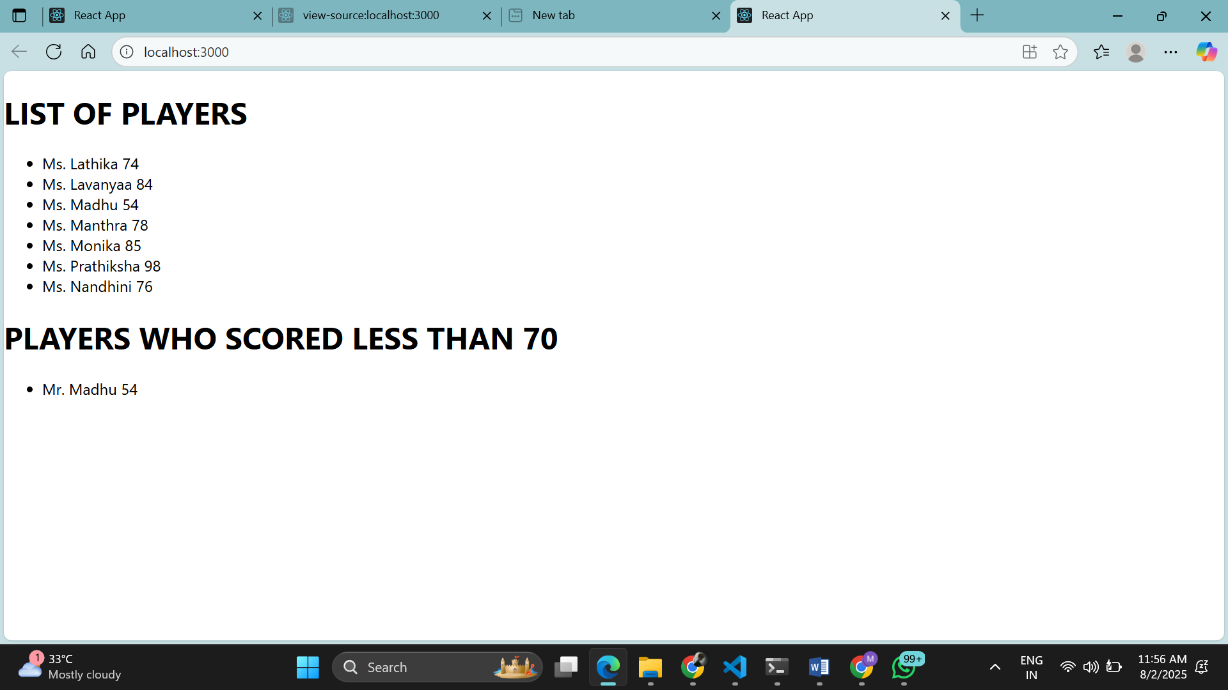

When flag =false

